# 新建JPA工程

## 新建

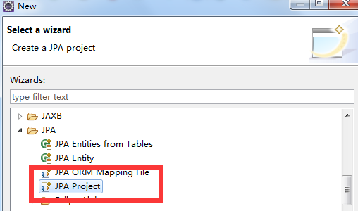

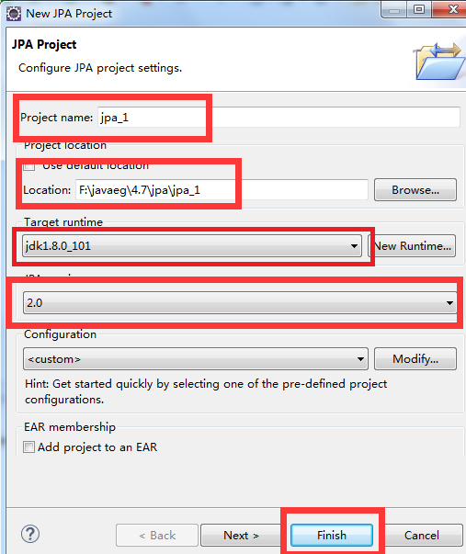

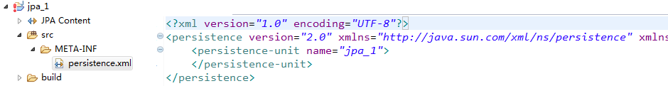

## 加入jar

1.hibernate-release-4.2.4.Final\lib\required\*.jar

2.hibernate-release-4.2.4.Final\lib\jpa\*.jar

3.数据库驱动的 jar 包

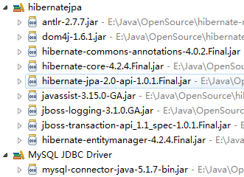

## persistence.xml

<persistence-unit name=*"jpa_test1"* transaction-type=*"RESOURCE_LOCAL"*>

<!--

配置使用什么 ORM 产品来作为 JPA 的实现

1. 实际上配置的是 javax.persistence.spi.PersistenceProvider 接口的实现类

2. 若 JPA 项目中只有一个 JPA 的实现产品, 则也可以不配置该节点.

-->

<provider>org.hibernate.ejb.HibernatePersistence</provider>

<!-- 添加持久化类 -->

<class>com.jpa.helloworld.Customer</class>

<properties>

<!-- 连接数据库的基本信息 -->

<property name=*"javax.persistence.jdbc.driver"* value=*"com.mysql.jdbc.Driver"*/>

<property name=*"javax.persistence.jdbc.url"* value=*"jdbc:mysql://127.0.0.1:3306/jpa"*/>

<property name=*"javax.persistence.jdbc.user"* value=*"root"*/>

<property name=*"javax.persistence.jdbc.password"* value=*"root"*/>

<!-- 配置 JPA 实现产品的基本属性. 配置 hibernate 的基本属性 -->

<property name=*"hibernate.format_sql"* value=*"true"*/>

<property name=*"hibernate.show_sql"* value=*"true"*/>

<property name=*"hibernate.hbm2ddl.auto"* value=*"update"*/>

</properties>

</persistence-unit>

# 测试

## 实体基本注解

@Table(name="JPA_CUTOMERS")

@Entity

**public** **class** Customer {

**private** Integer id;

**private** String lastName;

**private** String email;

**private** **int** age;

// @Column(name = "id") 如果与表名一致可省略

@GeneratedValue(strategy=GenerationType.***AUTO***)

@Id

**public** Integer getId() {

**return** id;

}

**public** **void** setId(Integer id) {

**this**.id = id;

}

@Column(name = "last_name")

**public** String getLastName() {

**return** lastName;

}

**public** **void** setLastName(String lastName) {

**this**.lastName = lastName;

}

**public** String getEmail() {

**return** email;

}

**public** **void** setEmail(String email) {

**this**.email = email;

}

**public** **int** getAge() {

**return** age;

}

**public** **void** setAge(**int** age) {

**this**.age = age;

}

}

## 持久化操作

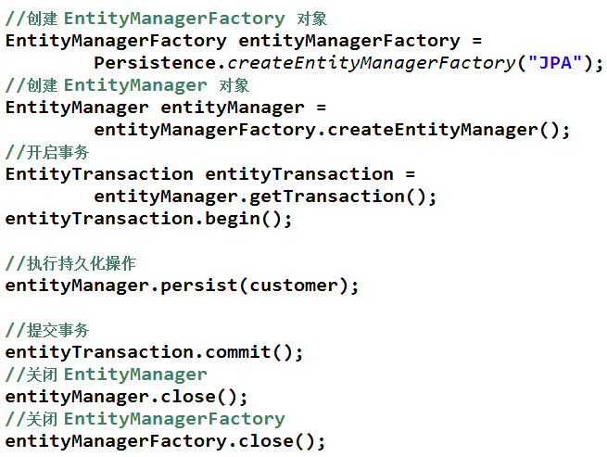

**public** **static** **void** main(String[] args) {

//1. 创建 EntitymanagerFactory

String persistenceUnitName = "jpa_test1";

EntityManagerFactory entityManagerFactory =

Persistence.*createEntityManagerFactory*(persistenceUnitName);

//2. 创建 EntityManager. 类似于 Hibernate 的 SessionFactory

EntityManager entityManager = entityManagerFactory.createEntityManager();

//3. 开启事务

EntityTransaction transaction = entityManager.getTransaction();

transaction.begin();

//4. 进行持久化操作

Customer customer = **new** Customer();

customer.setAge(12);

customer.setEmail("tom@atguigu.com");

customer.setLastName("Tom");

entityManager.persist(customer);

//5. 提交事务

transaction.commit();

//6. 关闭 EntityManager

entityManager.close();

//7. 关闭 EntityManagerFactory

entityManagerFactory.close();

}

## 结果



